Biometric Attendance System - Production-Ready Architecture
This document outlines the evolutionary design of the Attendix platform, transitioning it from a stateless processing tool to a scalable, persistent, and secure office management system.
🏗️ High-Level System Architecture
The system follows a classic 3-tier architecture for modularity and scalability.

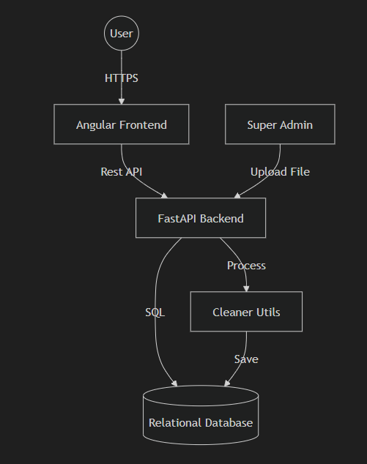

Components:-
- Frontend (Angular): Responsible for visualization, role-based routing, and interactive reports.
- Backend (FastAPI): Handles authentication, file processing logic (Pandas), and database orchestration.
- Database (PostgreSQL/MySQL): Stores employee records, attendance history, and audit logs.

🔐 Role-Based Access Control (RBAC) Strategy
The system enforces strict data isolation based on roles.
Role | Permissions | Data Scope
Super Admin | Full CRUD, User Management, File Upload | Entire Company
HR User | Read-Only Access, Reporting | Entire Company
Employee | Read-Only Access | Self-only (Record filtered by EmpID)
Authorization Mechanism
- JWT (JSON Web Tokens): Securely transmit claims (Role, EmpID) between client and server.
- Middleware: Backend decorators to verify permissions before executing sensitive operations (e.g., @require_role('SUPER_ADMIN')).
- Data Query Isolation: Queries for 'Employee' role will always append a WHERE emp_id = :session_id clause to prevent unauthorized data access.

🗄️ Database Design
A relational design ensures data integrity and historical accuracy.
1. Employee Master Table
Stores identity and authentication details.
- id (PK)
- employee_id (Unique, used in biometric logs)
- name
- email
- password_hash
- role (ENUM: SUPER_ADMIN, HR, EMPLOYEE)
- status (Active, Inactive)
- created_at, updated_at

2. Attendance Daily Logs (Aggregated)
Stores daily processed data for quick reporting.
- id (PK)
- employee_id (FK)
- date (Date)
- first_in (Time)
- last_out (Time)
- total_duration (Interval/Minutes)
- status (Present, Absent, Half-Day)
- source_file_id (FK for traceability)

3. File Upload Audit
Tracks source files for accountability.
- id (PK)
- filename
- uploaded_by (FK)
- upload_timestamp
- report_type (Type A or Type B)

🗺️ Normalization & Indexing
- Composite Index:
(employee_id, date) on logs to speed up monthly report generation.
- Partitioning: If scaling to thousands of employees, partition the attendance table by month/year.

🔄 Data Lifecycle & ETL Process
- Extract: Super Admin uploads raw
.xls/.csv.
- Transform:
  - Backend parses file using cleaner_utils.py.
  - Data is validated (Detects missing IDs, malformed timestamps).
  - Deduplication logic ensures same day records aren't duplicated.
- Load: Records are persisted to the database.
- Correction Flow: If an Admin modifies a record, the original biometric data is preserved, but a manual_correction flag and corrected_by column are updated.

Risks, Edge Cases & Future Extensions
Risks & Edge Cases
- Overlapping Uploads: Handling cases where an admin uploads the same month twice (Idempotency).
- Timezone Conflicts: Ensuring server and biometric device timestamps are synchronized (UTC recommended for storage).
- EmpID Mismatch: Handling raw files where EmpID doesn't exist in the Employee Master.
Future Extension Ideas
- Mobile Integration: Geo-fencing for remote check-ins.
- AI Forecasting: Predictive analytics for employee absence trends.
- Multitenancy: Supporting multiple offices or sub-companies in one instance.
- Leave Management Integration: Automatically marking "Present" vs "Leave" by syncing with HRMS.

> Verification Plan
This design will be verified against the requirements through structural review.
Structural Verification
- Ensure all 3 roles have distinct defined paths.
- Validate that the database schema supports "Correction Traceability".
- Confirm the architecture supports "Historical Data Preservation" via snapshots/persistence.

backend/
├── app/
│ ├── api/
│ │ ├── dependencies/ # Dependency injection
│ │ │ ├── __init__.py
│ │ │ ├── auth.py # get_current_user, check_admin, etc.
│ │ │ └── database.py # get_db dependency
│ │ │
│ │ └── v1/ # API versioning
│ │ ├── __init__.py
│ │ └── endpoints/ # Route handlers ONLY
│ │ ├── __init__.py
│ │ ├── admin.py ✅ Routes only, calls services
│ │ ├── attendance.py ✅ Routes only
│ │ ├── auth.py ✅ Routes only
│ │ ├── leave.py ✅ Routes only
│ │ └── records.py ✅ Routes only
│ │
│ ├── core/
│ │ ├── __init__.py
│ │ ├── config.py # Settings, environment variables
│ │ ├── database.py # Database connection
│ │ ├── security.py # Password hashing, JWT
│ │ └── exceptions.py # Custom exceptions
│ │
│ ├── models/
│ │ ├── __init__.py
│ │ ├── employee.py # Employee model only
│ │ ├── attendance.py # Attendance model only
│ │ ├── leave.py # Leave models only
│ │ └── file_upload.py # FileUploadLog model
│ │
│ ├── schemas/ # Pydantic schemas (request/response)
│ │ ├── __init__.py
│ │ ├── employee.py # EmployeeCreate, EmployeeResponse
│ │ ├── attendance.py # AttendanceUpdate, AttendanceResponse
│ │ ├── auth.py # LoginRequest, TokenResponse
│ │ └── leave.py # LeaveApplyRequest, LeaveResponse
│ │
│ ├── services/ # Business logic layer
│ │ ├── __init__.py
│ │ ├── employee_service.py # Employee CRUD operations
│ │ ├── attendance_service.py # Attendance business logic
│ │ ├── auth_service.py # Authentication logic
│ │ ├── leave_service.py # Leave management logic
│ │ ├── file_service.py # File upload/processing
│ │ └── email_service.py # Email sending (already exists)
│ │
│ ├── repositories/ # Database access layer (optional but recommended)
│ │ ├── __init__.py
│ │ ├── employee_repository.py
│ │ ├── attendance_repository.py
│ │ └── leave_repository.py
│ │
│ ├── utils/ # Helper functions
│ │ ├── __init__.py
│ │ ├── file_utils.py # File hashing, validation
│ │ ├── date_utils.py # Date calculations
│ │ ├── azure_utils.py # Azure blob operations (exists)
│ │ └── validators.py # Custom validators
│ │
│ └── main.py # FastAPI app initialization
│
├── tests/ # Test directory
│ ├── __init__.py
│ ├── test_auth.py
│ ├── test_attendance.py
│ └── test_leave.py
│
├── alembic/ # Database migrations (recommended)
│ └── versions/
│
├── .env
├── requirements.txt
└── README.md

